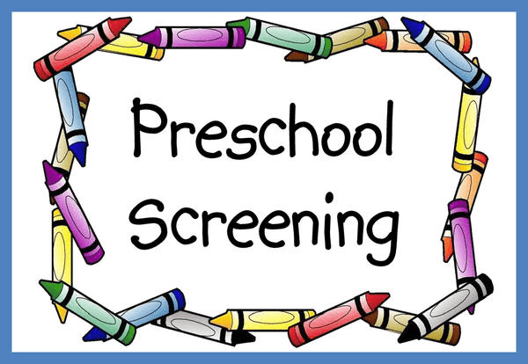
Why does my child need an early childhood (preschool) screening?

All Minnesota children need Early Childhood Screening. It is recommended at age three and is required for kindergarten.
Preschool screening helps identify potential problems in your child’s health and development, and is a perfect time to find out about what early learning opportunities are available for your child, and to make sure the right supports are available to help your child learn and grow.
Chokio-Alberta School is offering Early Childhood Screening on Monday, August 19, 2024 for all families in the school district who have a child or children ages 3-5 years old.
There is no charge for preschool screening and it only needs to be completed once. If your child has already had it done by another agency, school or family physician, please forward the screening results to Jennifer Wulff at ‘jwulff@chokioalberta.k12.mn.us’.
If you would like your child screened, please call the school at 320-324-7131 to make an appointment.
Parents may also opt out, decline, refuse or conscientiously object to the screening by submitting a statement in writing to the district where the child will attend kindergarten per Minnesota Statutes 121A.17.
